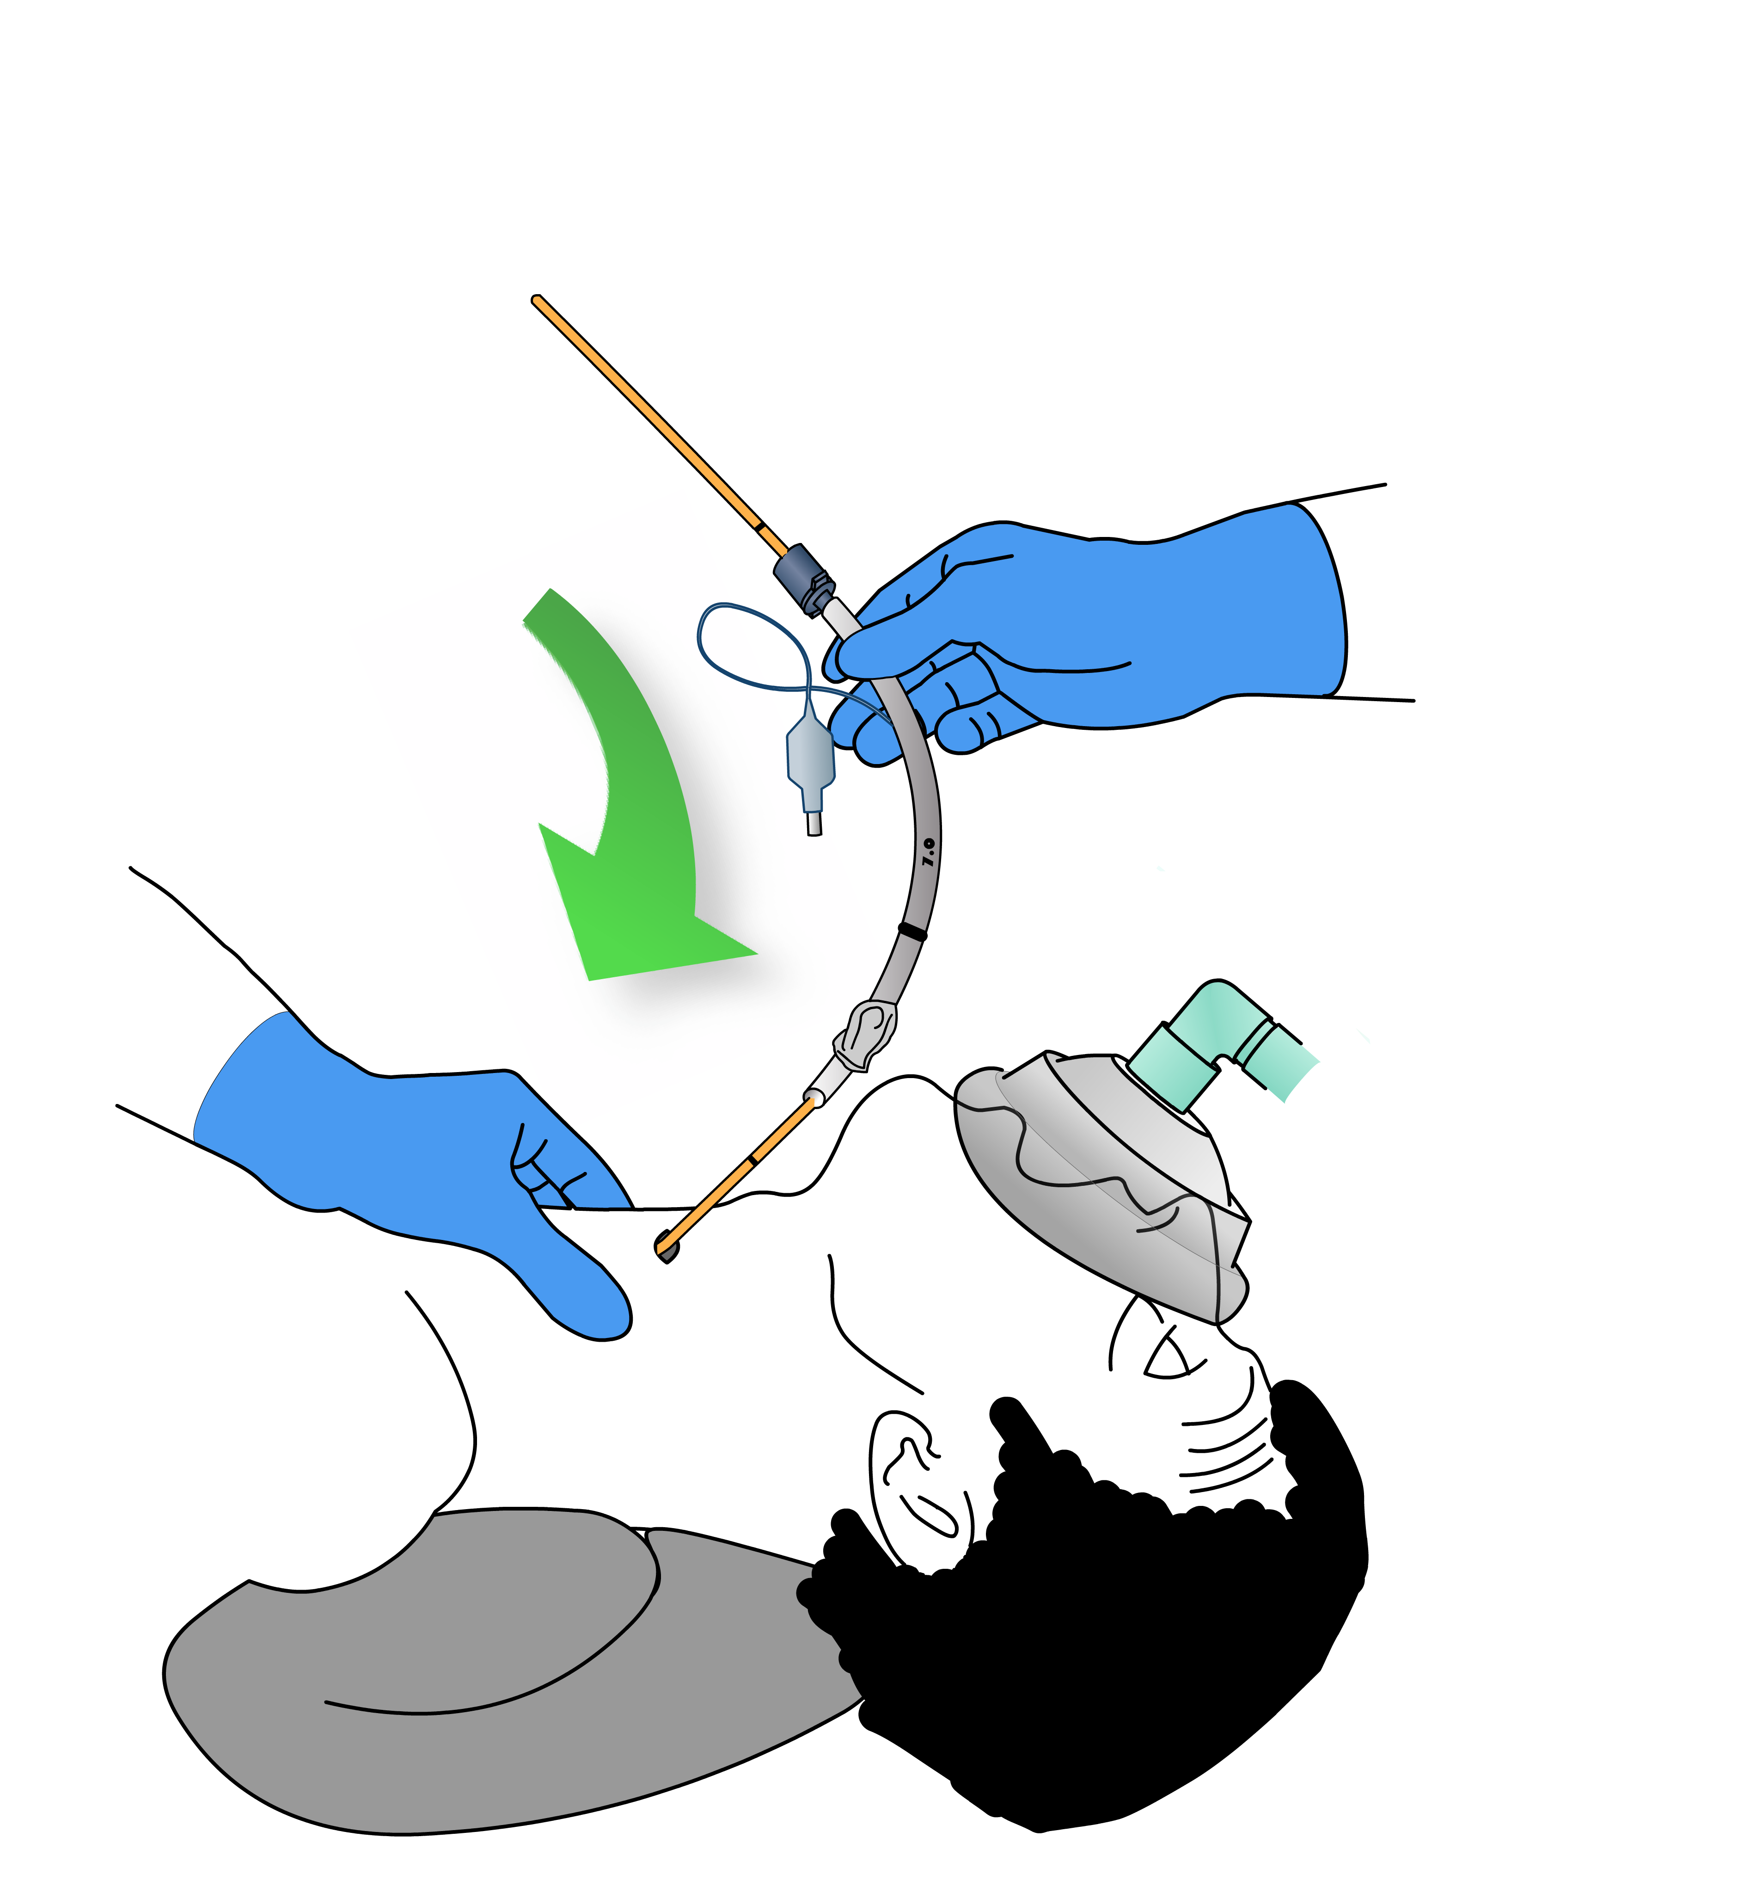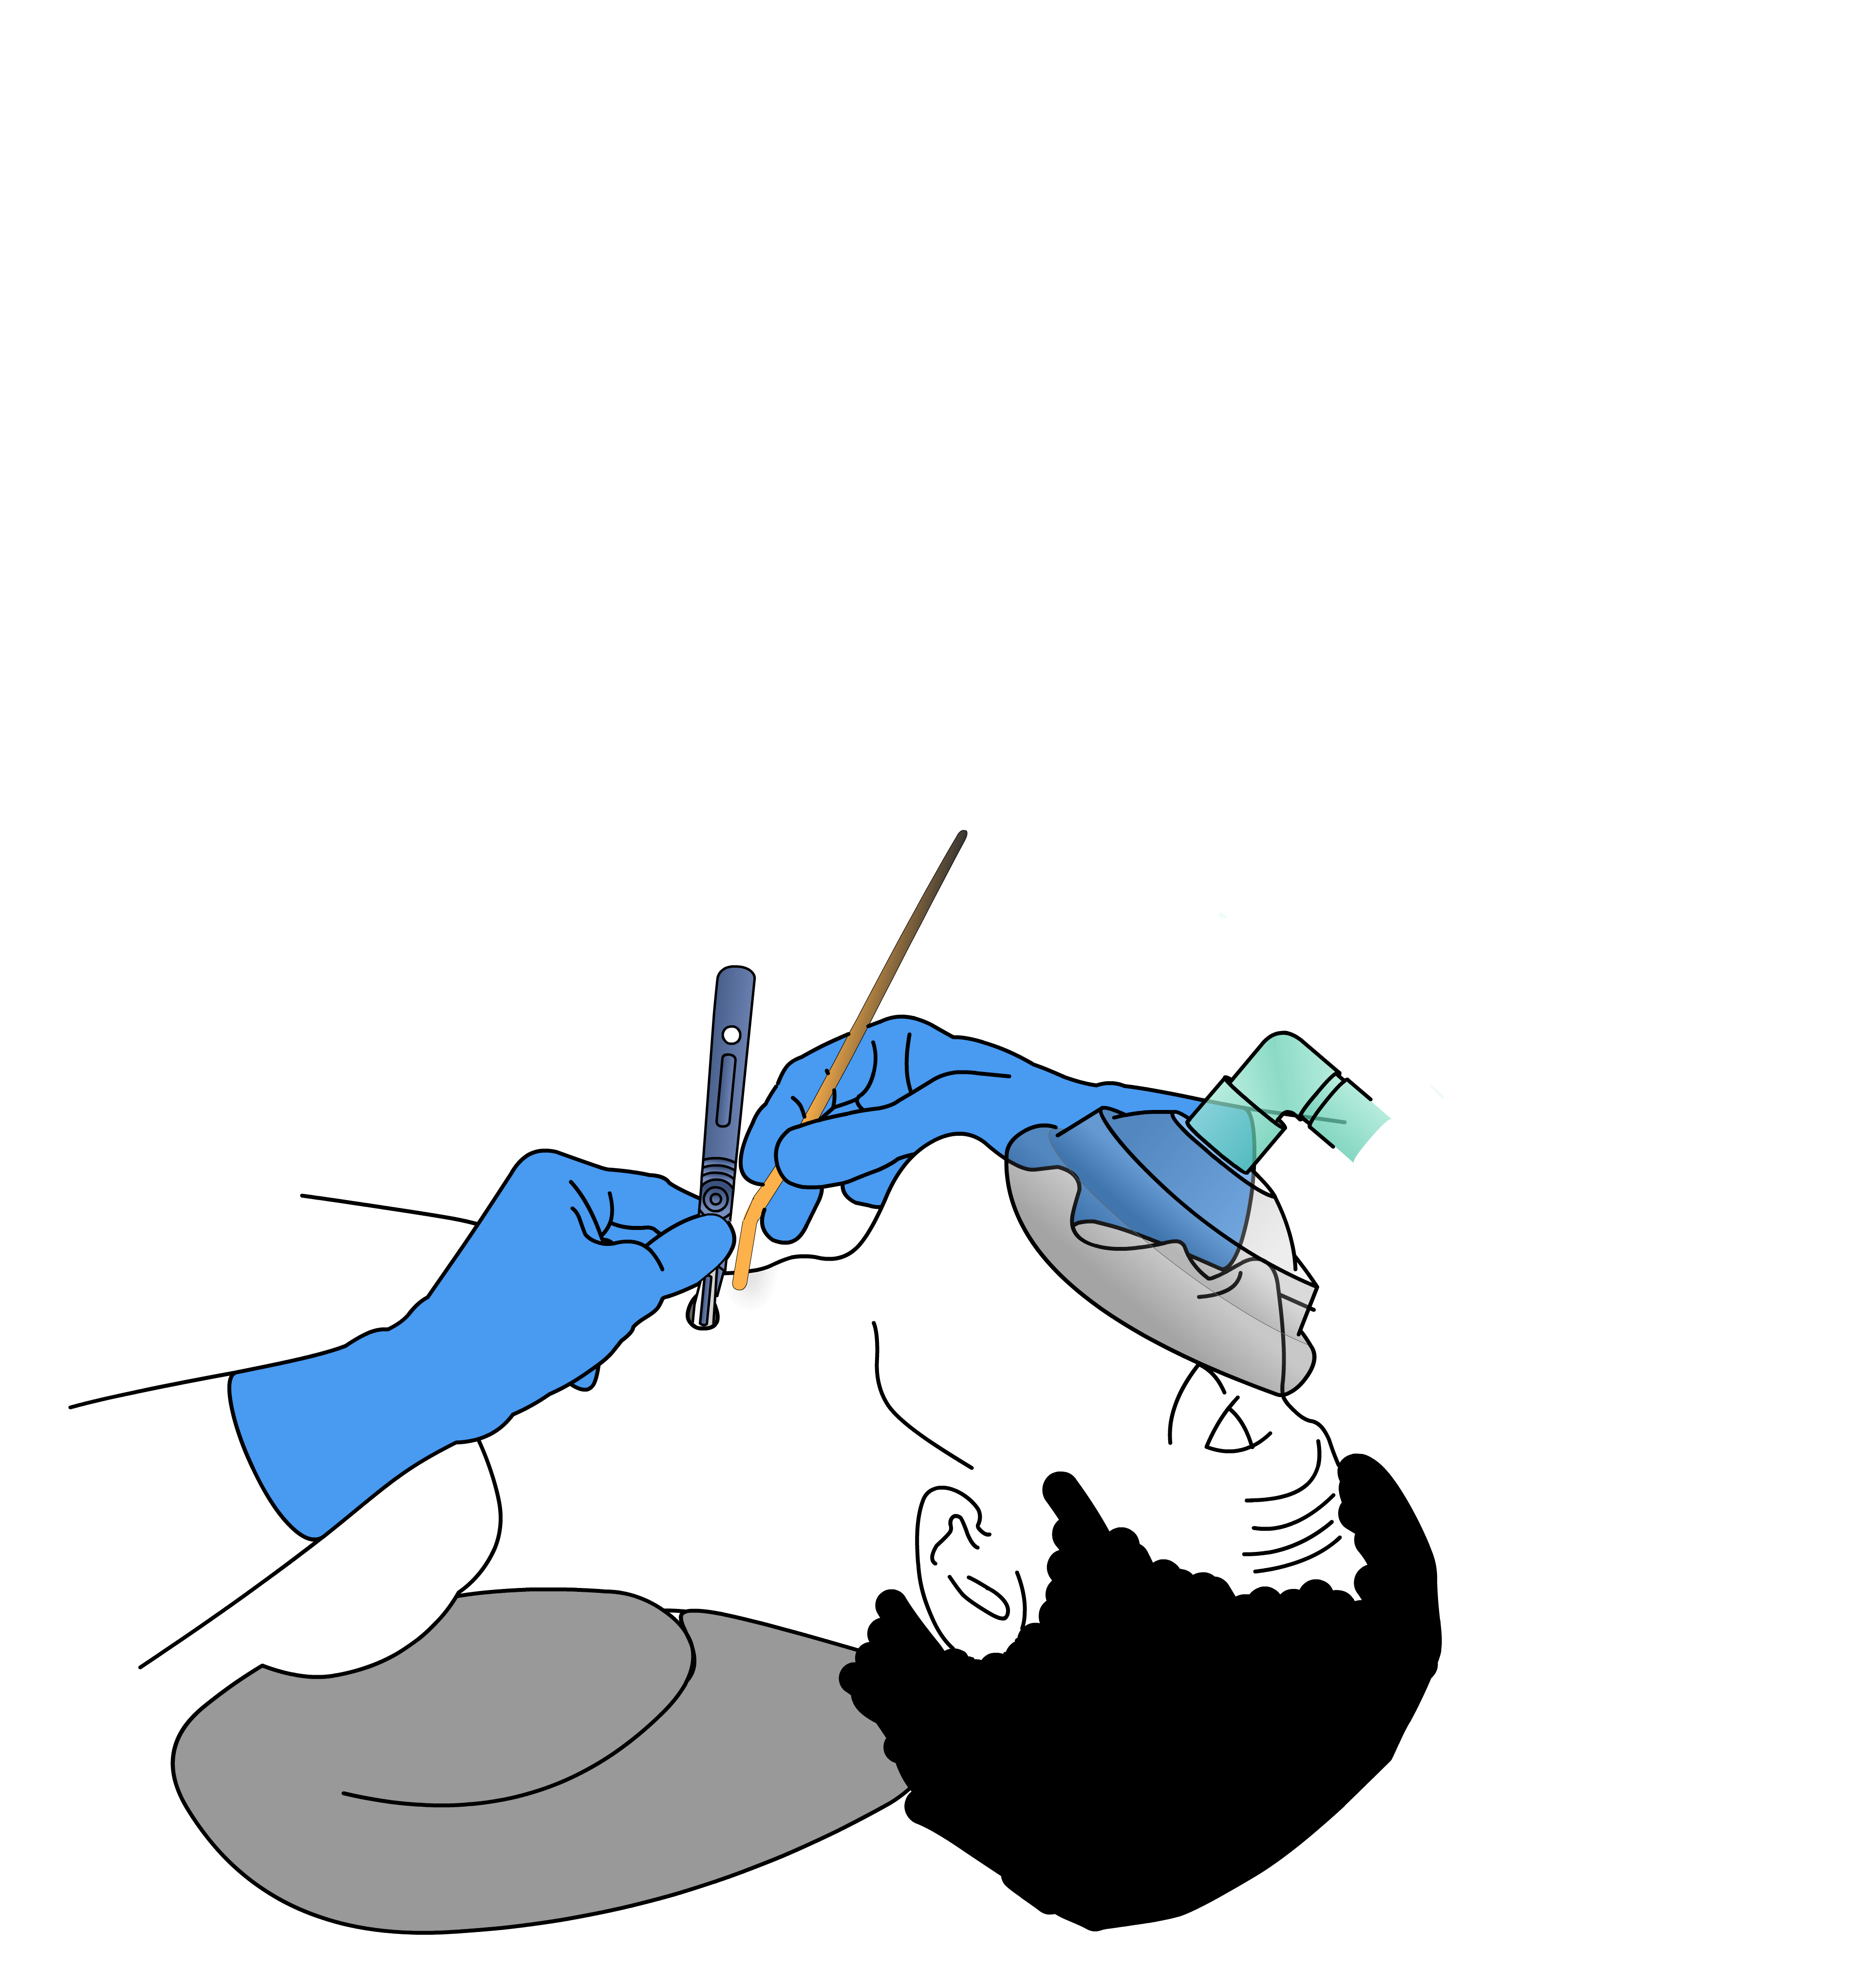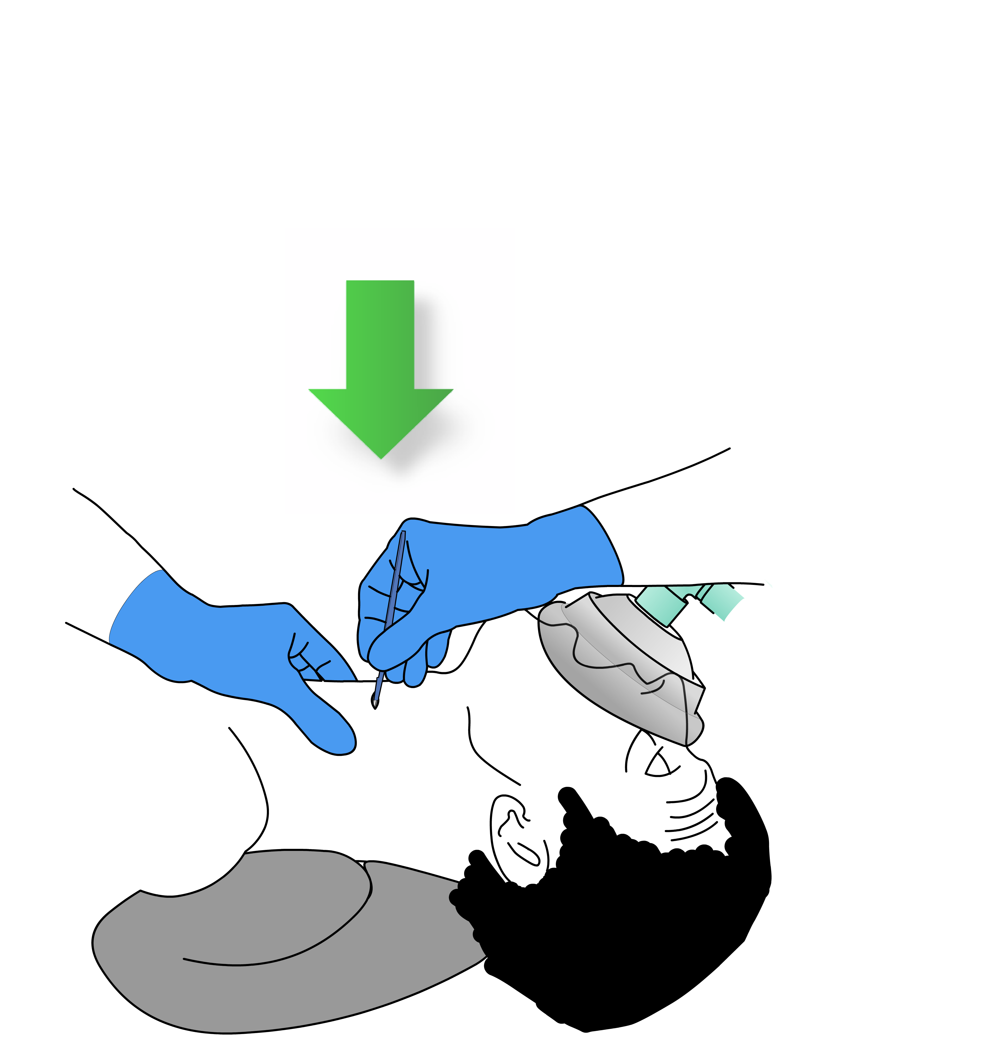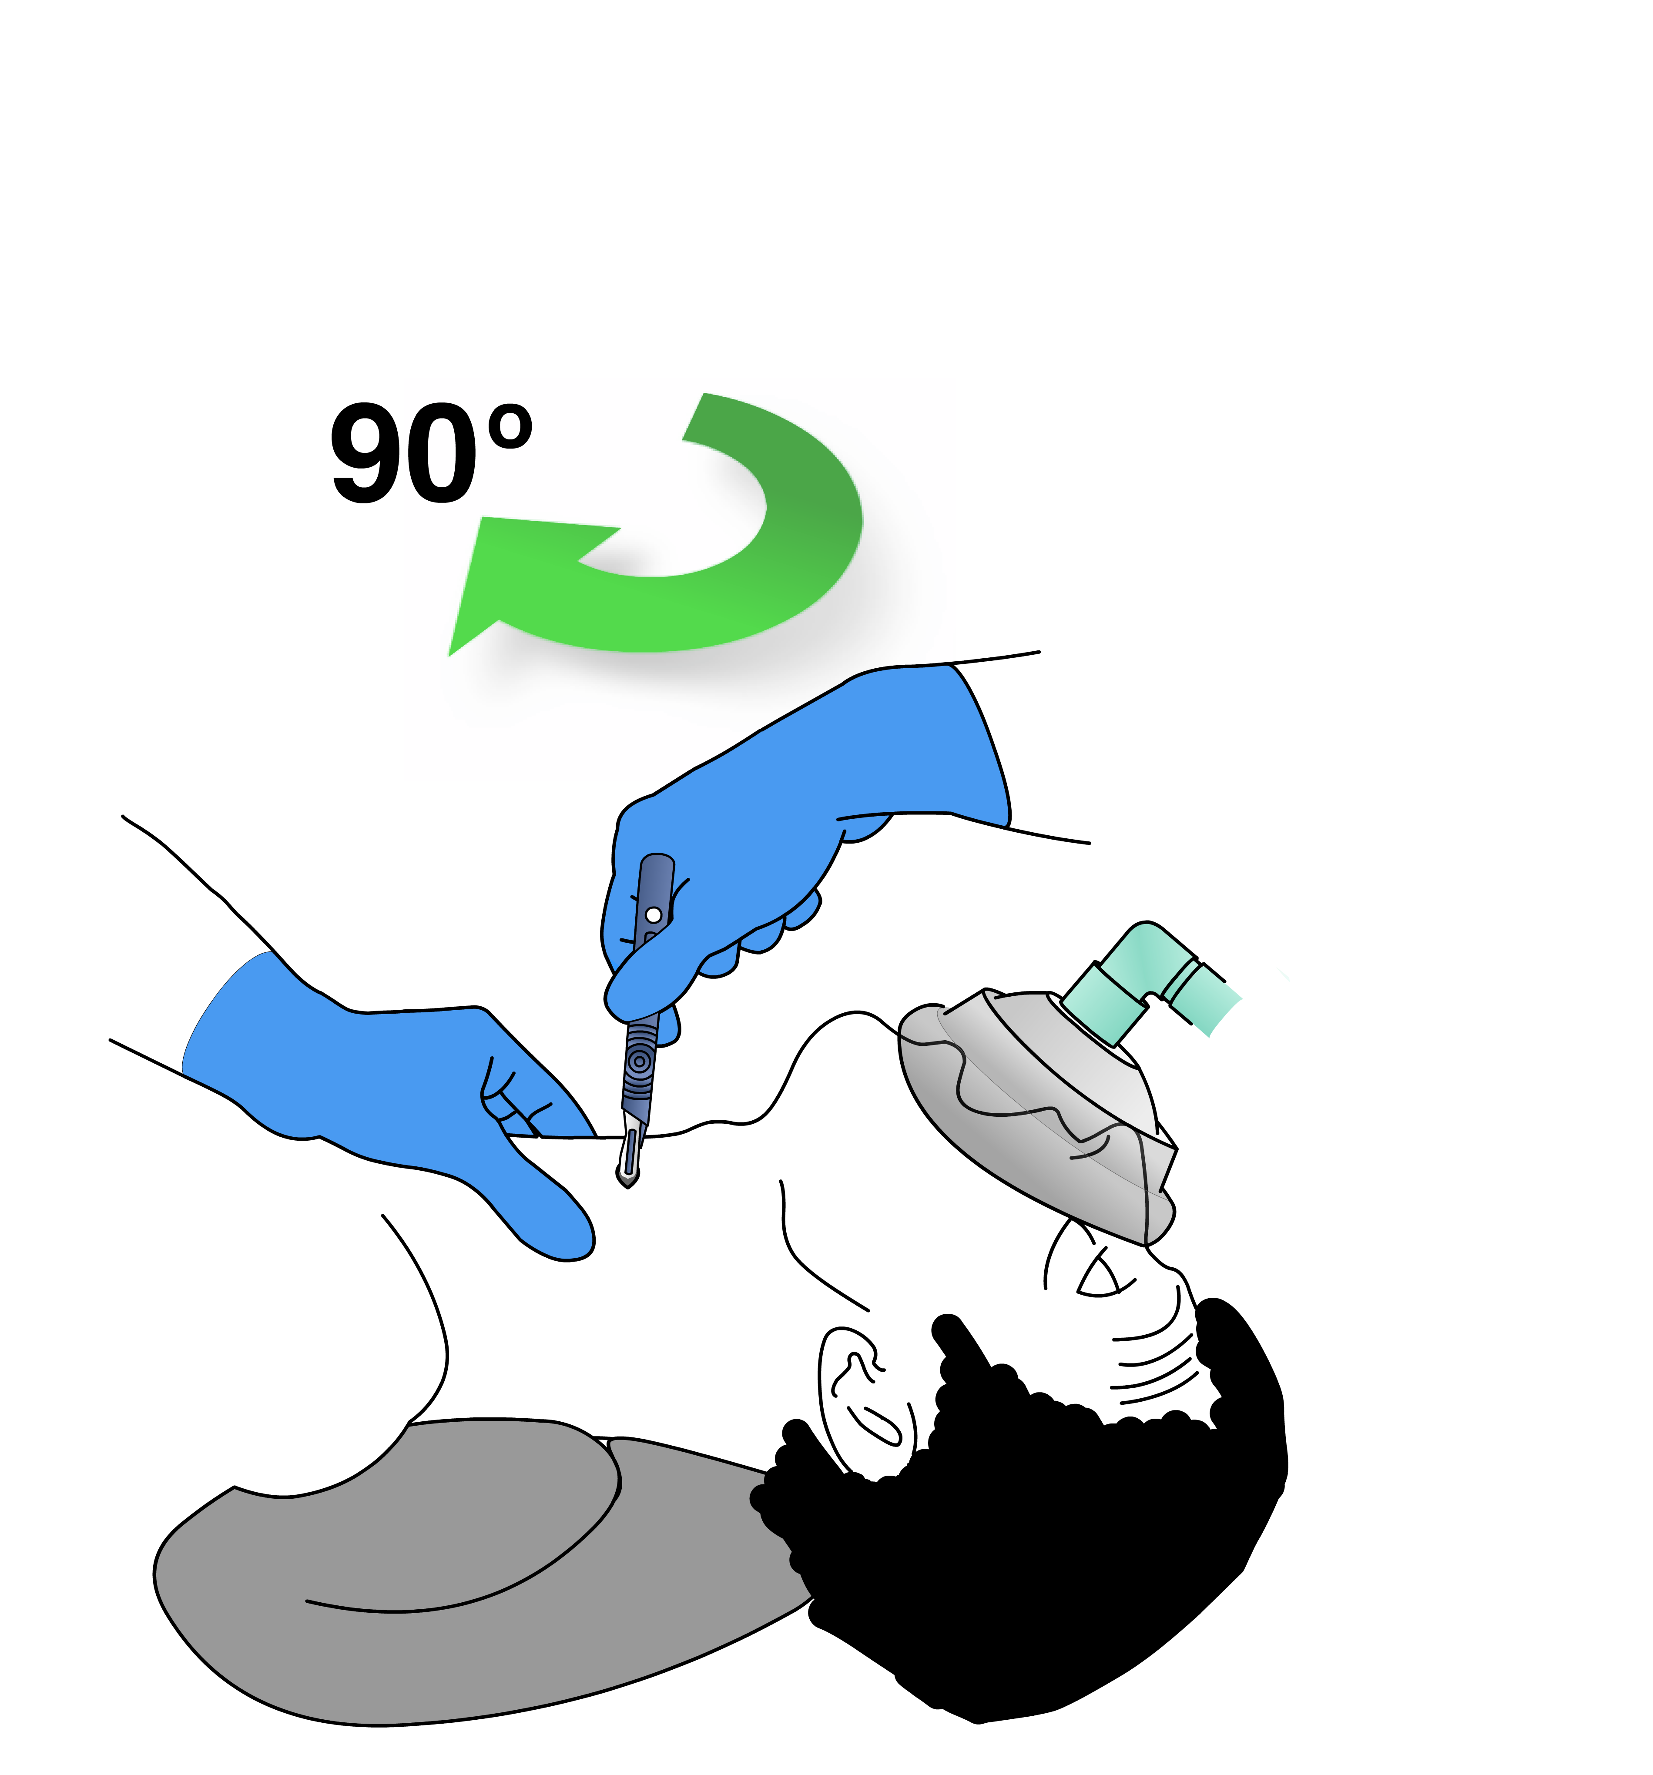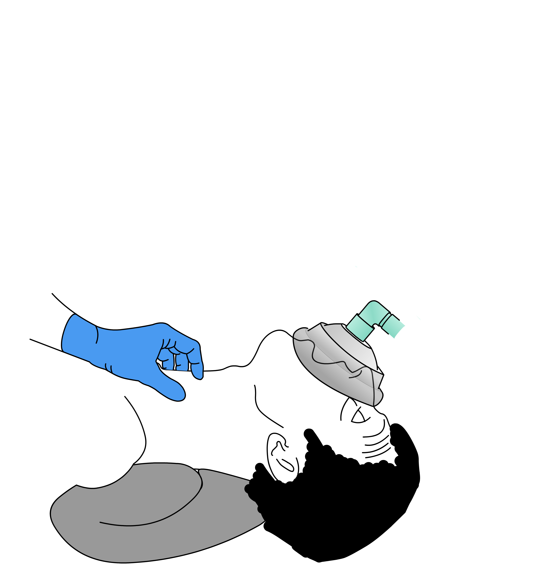

ETT 6.0

**Plan D**

transverse stab incision

Scalpel size 10 blade, rotate, bougie, size 6.0 ETT

laryngeal handshake

Ensure paralysis

coude tip vertically

rotate

down blade

Stab, Twist, Bougie, Tube